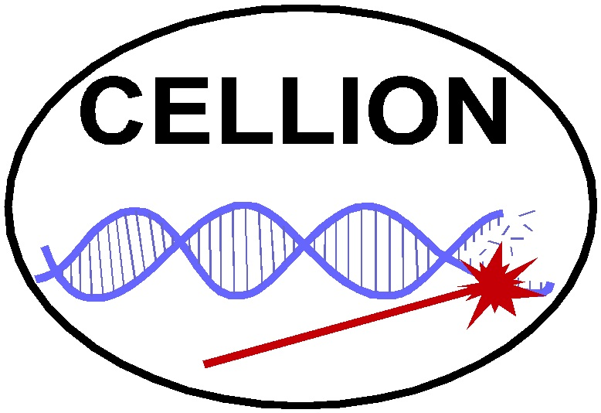

MC RTN project CELLION
Studies on cellular response to targeted single ions using nanotechnology
Mid–term Meeting, Bordeaux, 3–5 February 3rd – 5th 2006
Preliminary schedule
Friday February 3rd
Arrival and registration in hotel XXX
Opening session
17:00 Welcome and Opening (Philippe Moretto, Zbigniew Stachura)
17:10 Introduction by Commisision's representative and external expert
17:25 Co-ordinators’ reports (Zbigniew Stachura, Kevin Prise, Tilman Butz)
Saturday, February 4th
08:30 Presentation of the teams (IFJ, GCI, GSI, INFN, CM UJ)
(both the scientist-in-charge and the Young Researcher(s)
10:00 Coffee break
10:30 Presentation of the teams, cont. (CENBG, Leipzig, Lund, Surrey, Uppsala)
12:00 Lunch
13:00 Meeting between Commission and Young Researchers
14:00 Coffee break
14:30 General Assembly of the CELLION
– Questions to Commission representatives
– Remarks from the Project Officer
– Administrative issues
– Discussion of open questions
20:00 Dinner
Sunday, February 5th
9:30 Concluding session
– Preparation to reporting (second year of the project)
– Strategy for the remaining period (comments, impressions, questions).
11:30 End of the Mid-term Meeting

